|  |
| --- |
| **Exp No: 1- A**  **Date: 21/ 11/22** |

**STUDENT GRADE ANALYSIS**

**Aim:**

To draw flowchart and write algorithm for the following problem.

**ALGORITHM:**

**STEP 1:** Start.

**STEP 2:** Get the Number of students (N)

**STEP 3:** Assign i = 0.

**STEP 4:** Check for the condition i < N.

**4.1:** If True, Get Name, Roll.no and Marks m1, m2, m3, m4, m5.

**4.2:** Calculate Total = m1 + m2 + m3 + m4 + m5 and Average = Total / 5

**4.3:** Display Name and Roll Number.

**4.4:** Check for condition avg >= 30 and avg < 50.

**4.4.1:** If True Display the message your grade is c" and increase i value by 1.

**4.5:** Check for condition avg > 50 and avg < 80

**4.5.1:** If True Display the message "You grade is B" and increase i value by 1.

**4.6:** Check for the condition avg > 80 and avg ≤ 100

**4.6.1:** If True Display the message. "Your grade is A" and increase i value by 1.

**4.7:** Check for the condition avg < 30

**4.7.1:** If True Display the message "Your grade is D".

**STEP 5:** If False, goto step 6

**STEP 6:** Stop.

**FLOWCHART :**

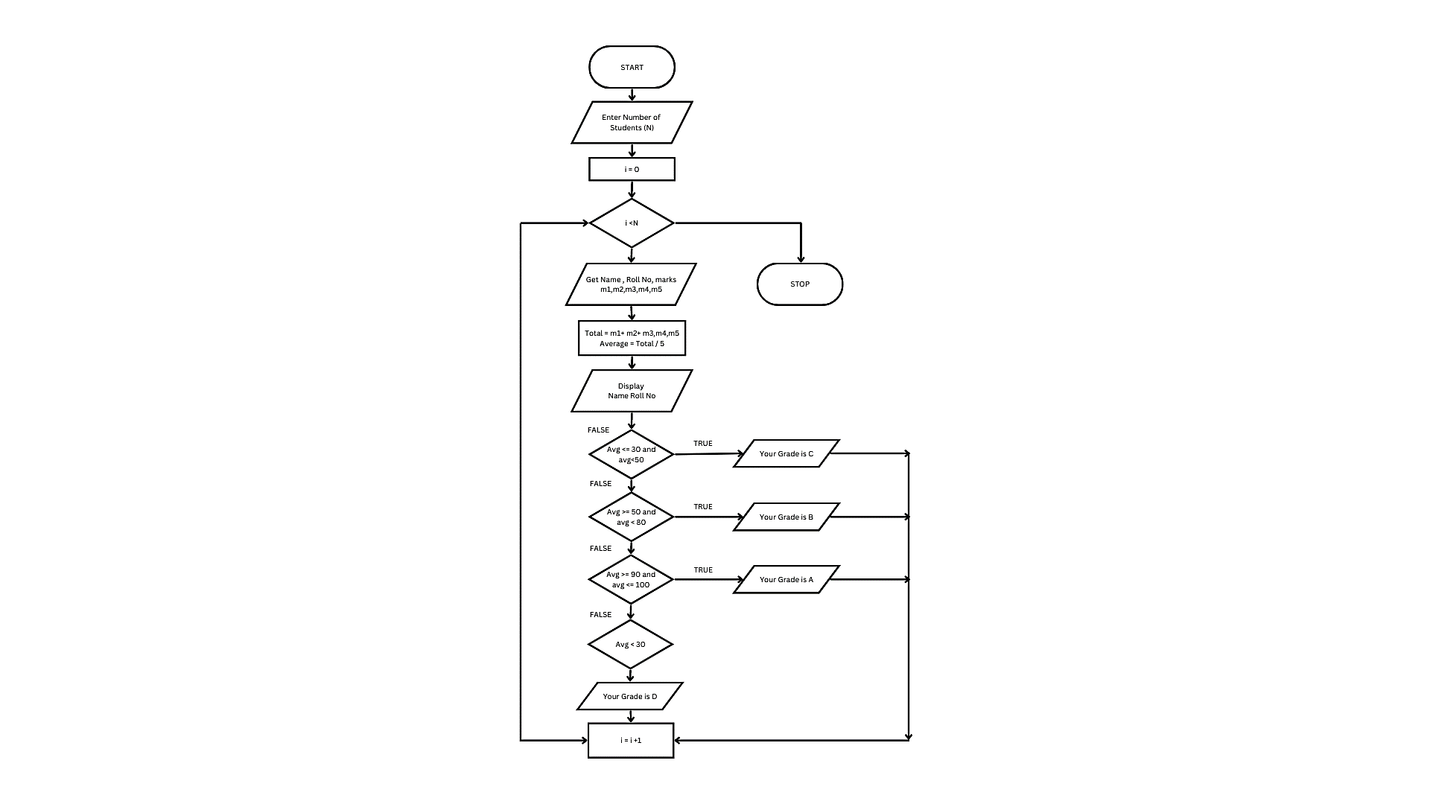

**PSEUDO CODE:**

START

GET VALUE OF N

Assigni=0

CHECK i<N

IF TRUE

GET Name,Roll no and Marks m1,m2,m3m4,m5

CALCULATE Total = m1+m2+m3+m4+m5 and Average =Total/5

DISPLAY Name and Roll Number

IF avg>=30 and avg<50

PRINTgrade is C

i=i+1

IF avg>50 and avg<80

PRINT grade is B

i=i+1

IF avg>80 and avg<=100

PRINT grade is A

i=i+1

IF avg<30

PRINT grade is D

END IF

STOP

**RESULT:**

Thus, the algorithm and flowchart are written for the given problem.

|  |
| --- |
| **Exp No: 1- B**  **Date: 21/ 11/22** |

**CALCULATING ELECTRIC BILL**

**AIM:**

To draw flowchart and write algorithm for calculating the electric bill.

**ALGORITHM:**

**STEP 1:** Start.

**STEP 2:** Enter consumer Unit N

**STEP 3:**Check for the condition N<=100 If true ,no charges to pay

**STEP 4:** Check for condition N<=200 If true.

**4.1**: Calculate E.C using formula FC = 20, DC = 18, EC = (N – 100) * 1.5

**4.2:** Calculate the Total charges = FC + DC + EC

**4.3:** Display amount needed to pay and go to stop.

**STEP 5:** Check condition N<=500 of take.

**5.1:** Calculate EC using formula. FC = 30, DC = 48, EC = (100*2)+(N - 200) * 3.5

**5.2:** Calculate the Total charges = FC + DC + EC

**5.3:** Display amount need to pay and go to stop.

**STEP 5:** Check for the condition N>500 If true.

**5.1:** Calculate the E.C using FC=75, DC=100, EC = (100 * 3.5) + (300*4.6)+(N - 500) * 6

**5.2:** Calculate Total charges = FC + DC + EC

**5.3:** Display the amount need to pay and go to stop

**STEP 6:** Stop.

**FLOWCHART:**

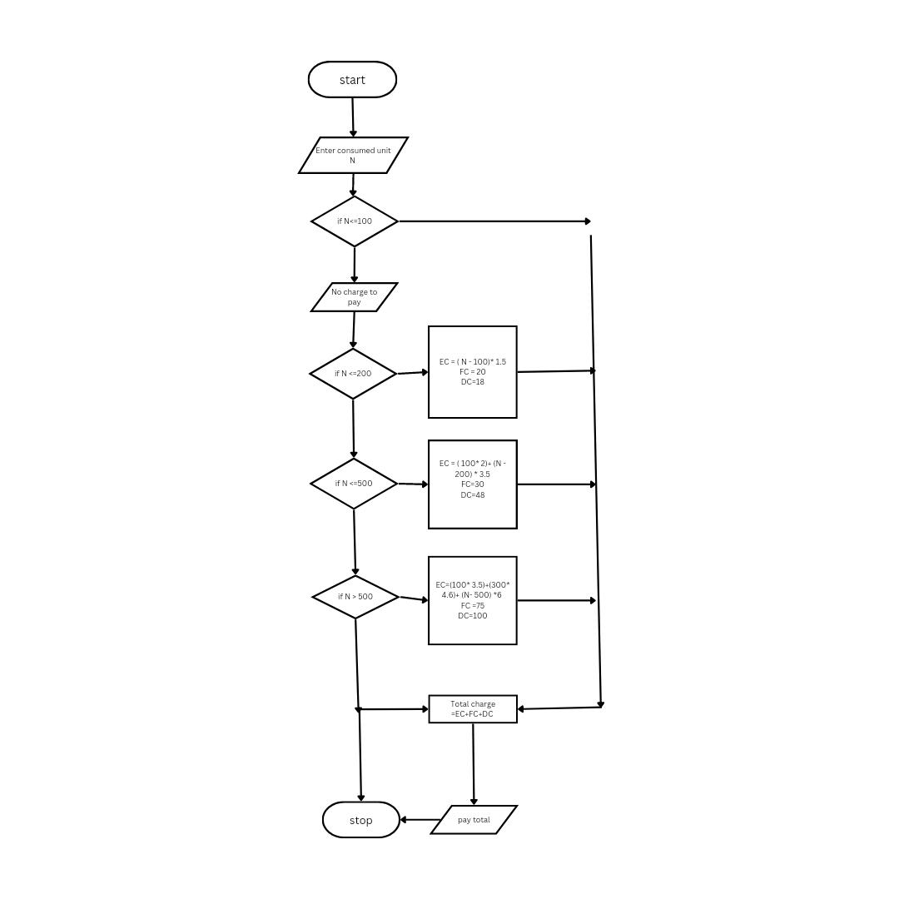

**PSEUDO CODE:**

START

GET N

IF N<=100 THEN

PRINT “NO CHARGE”

IF N<=200 THEN

EC=(N-100)*1.5

FC=20,DC=18

Total=3C+FC+DC

PRINT Total

IF N<=500

EC=(100*2)+(N-200)*3.5

FC=30,DC=48

Total=EC+FC+DC

PRINT Total

IF N>500

EC=(100*3.5)+(300*4.6)+(N-500)

FC=75,DC=100

Total=EC+FC+DC

PRINT Total

END IF

STOP

**RESULT:**

Thus, the algorithm and the flowchart is written for the given problem.

|  |
| --- |
| **Exp No: 1- C**  **Date: 21/ 11/22** |

**CALCULATE WEIGHT OF STEEL BAR**

**AIM:**

To draw flowchart and write algorithm for calculating the weight of a steel bar

**ALGORITHM:**

**STEP 1:** Start.

**STEP 2:** Get the diameter d of a steel bar

**STEP 3:** If d>=8mm and <=20mm then Calculate the W

as (d*d)/162

Print W

**STEP 4:** Else print as not available

**STEP 5 :** Stop

**FLOWCHART:**

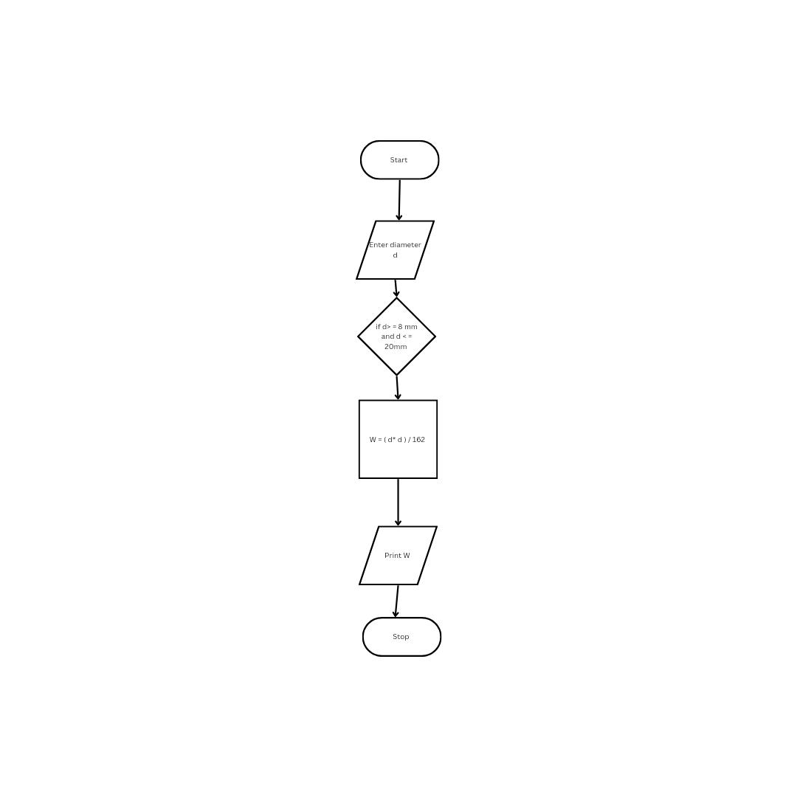

**PSEUDO** **CODE:**

START

READ Diameter d

IF d>=8mm and <=20mm

CALCULATE W=(d*d)/162

PRINT W

ELSE

TW+W

ELSE not

END IF

STOP

**RESULT:**

Thus, the algorithm and the flowchart is given for the problem.

|  |  |
| --- | --- |
| **Exp No: 1- D**  **Date:29/ 11/22** | **CALCULATE WEIGHT OF A MOTORBIKE** |

**AIM:**

To draw flowchart and write algorithm for calculating weight of a motorbike.

**ALGORITHM:**

**STEP 1:** Start.

**STEP 2:** Get the type of motorcycles M

**STEP 3:** Based on type M ,choose weight as

. **3.1** **:**if M= Chopper,W= 317 Kg

**3.2 :**if M =Bobber,W = 306 Kg

**3.3 :** if M =Cruiser, W=256 Kg

**3.4 :** if M=Scrambler, W=182 Kg

**STEP 4:**Else print as cannot find the weight

**STEP 5:** Print the weight

**STEP 6:** Stop

**FLOWCHART:**

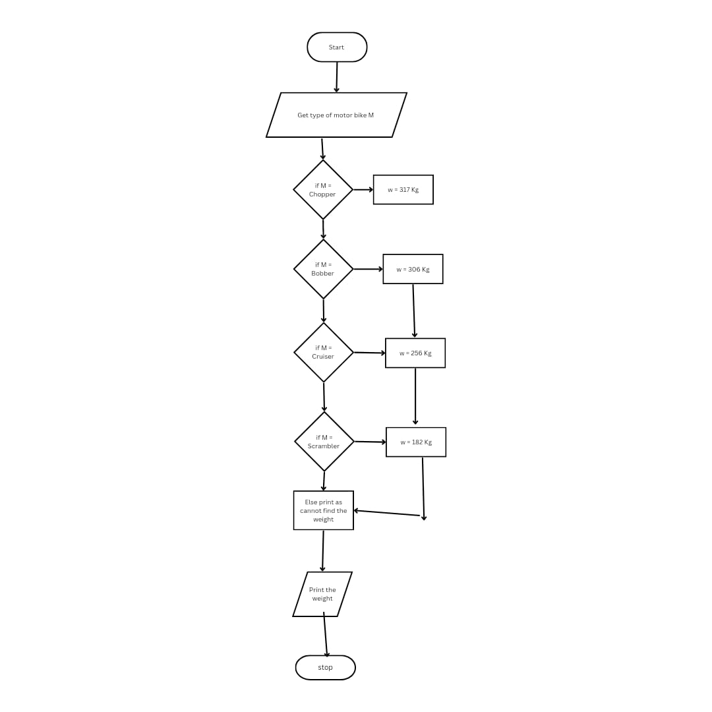

**PSEUDO CODE:**

START

GET the types of motorcycles M

IF M=Chopper

PRINT W =317Kg

IF M =Bobber

PRINT W =306Kg

IF M =Cruiser

PRINT W = 256 Kg

IF M=Scrambler

PRINTW=182Kg

ELSE PRINT cannot find the W

END IF

STOP

**RESULT:**

Thus, the flowchart and the algorithm is written for the problem.

|  |  |
| --- | --- |
| **Exp No: 1- E**  **Date:29/ 11/22** | **CALCULATE ELECTRIC CURRENT IN**  **3 PHASE A/C CIRCUIT** |

**AIM:**

To draw flowchart and write algorithm. to- calculate electrical current in 3 phase AC circuit.

**ALGORITHM:**

**STEP 1:** Start

**STEP 2:** Get value of pf (power factor)

**STEP 3:** Get value of Current (I).

**STEP 4:** Get value of voltage (V)

**STEP 5:** Calculate P using the formula P= 1.732*pf*I*V.

**STEP 6:** Display the value of P.

**STEP 7:** Stop

**FLOWCHART:**

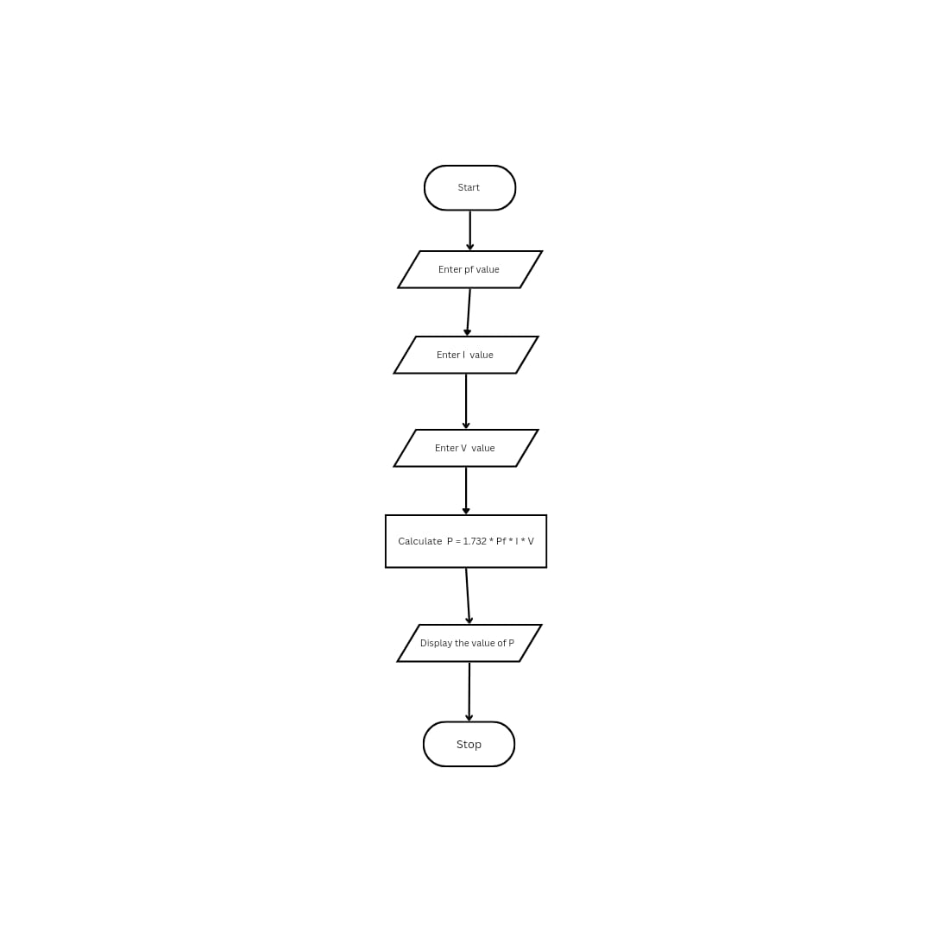

**PSEUDO CODE:**

START

GET pf,I,V

P=1.732*pf*V*I

PRINT P

STOP

**RESULT:**

Thus the flowchart and the algorithm is written for the given problem.

|  |  |
| --- | --- |
| **Exp No: 1- F**  **Date:29/ 11/22** | **RETAIL SHOP BILLING** |

**AIM:**

To draw the flowchart and write the algorithm for the retail shop billing.

**ALGORITHM:**

**STEP 1:** Start

**STEP 2:** Get the Bill number.

**STEP 3:** Get costumer name, address and other details

**STEP 4:** Get the value of total no. of Items purchased.

**STEP 5:** Initialize the values for i =0, Total =0, subtotal =0

**STEP 6:** Check if condition i<=n.

**6.1:** If true, get Item name, Price, Quantity and the discount.

**6.2:** Calculate the subtotal = Quantity *Price -discount .

**6.3:** Calculate the Total = Total + subtotal

**6.4:** Increment the value of i and goto step 6.

**STEP 7:** If False, get the GST value.

**STEP 8:** Calculate Total bill amount = Total + GST/100

**STEP 9:** Display the Total Bill amount

**STEP 10:** Stop.

**FLOWCHART:**

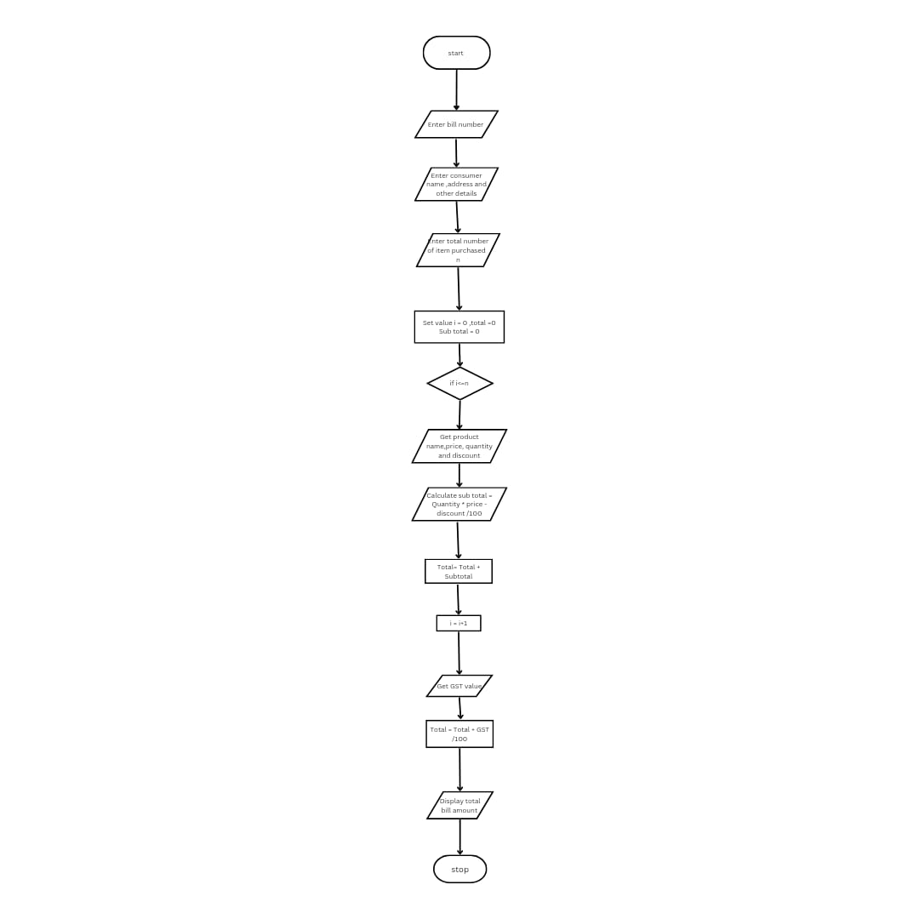

**PSEUDO CODE:**

START

GET Bill number

GET costumer name address and other details

GET n

INITIALIZE i=0,total=0, subtotal =0

IF i<=n THEN

GET Name,Price,Quantity and Discount

CALCULATE Subtotal=Quantity *Price -Discount

Total =Total +Subtotal

i=i+1

ELSE:

GET GST

Total_bill=Total+GST/100

PRINT Total_bill

END IF ELSE

STOP

**RESULT:**

Thus, the flowchart and the algorithm is written for the problem

|  |  |
| --- | --- |
| **Exp No: 1- G**  **Date:29/ 11/22** | **SINE SERIES.** |

**AIM:**

To draw flowchart and write algorithm for the sine series.

**ALGORITHM**:

**STEP 1:** Start.

**STEP 2:** Get x and i

**STEP 3:** Initialize fact 1 and i=1

**STEP 4:** For k= 1 to j

**4.1:**Calculate fact as fact*k

**4.2:**Find the factorial as x

. **4.3:**Increament i by 2

**STEP 5:** Repeat step 4 for i times

**STEP 6:** Display the sine series result

**STEP 7:** Stop.

**FLOWCHART:**

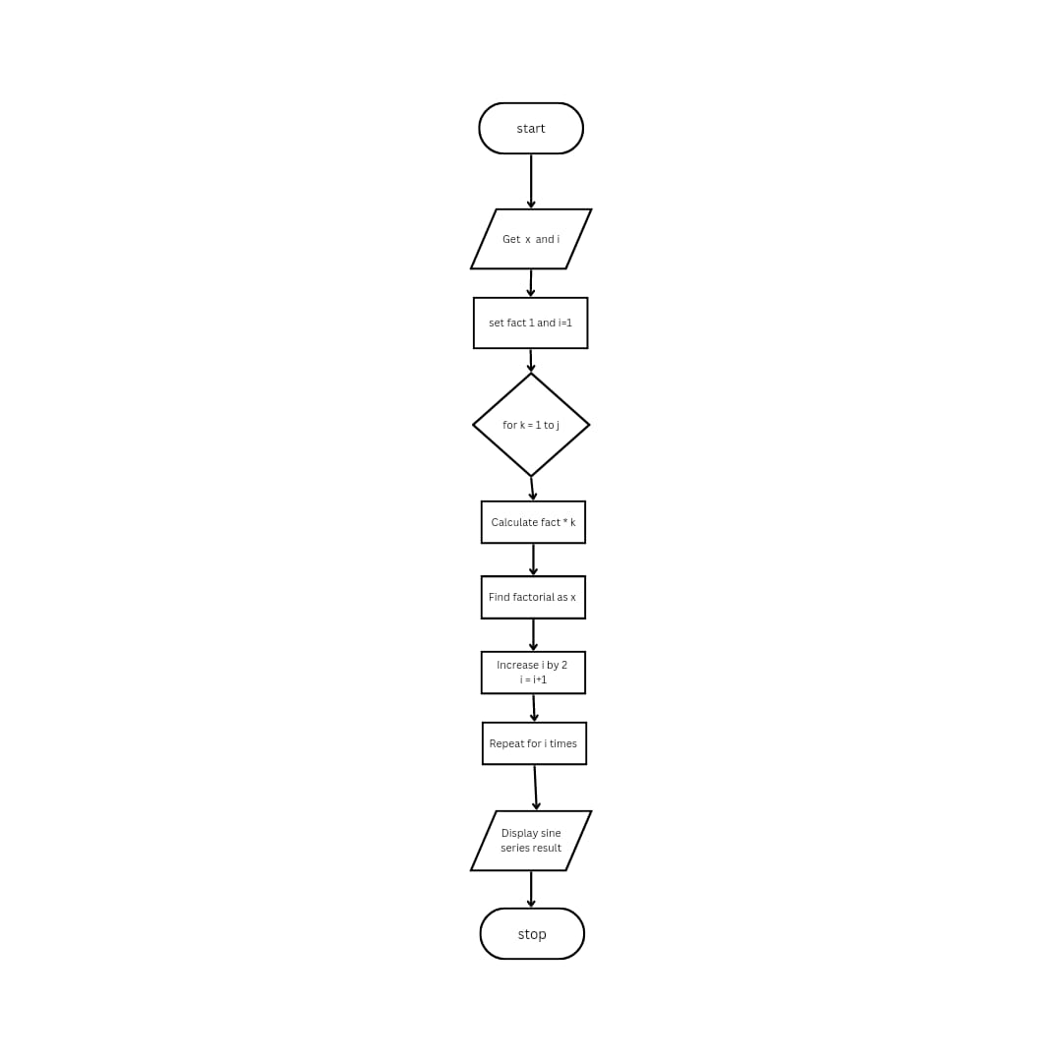

**PSEUDO CODE:**

START

GET x and I

INITIALIZE fact =1 and i=1

FOR k =1to j

CALCULATE fact =fact*k

CALCULATE factorial as x

i=i+2

FOR i times

DISPLAY sine series

END FOR

STOP

**RESULT:**

Thus, the flowchart and the algorithm is written for the problem

**FLOWCHART:**

* Flowchart A graphical representation of the logic for the problem solving.
* The purpose of the flowchart is making the logic of the program in a visual representation
* Flowcharts is a diagram made up of boxes, diamonds, and other shapes, connected by arrows.
* Each shape represents a step-in process and arrows show the order in which they occur.

|  |  |
| --- | --- |
|  | OVAL – TERMINAL SYMBOL |
|  | Parallelogram - Input/ Output symbol |
|  | Rectangle - Process symbol |
|  | Diamond - Decision symbol |
|  | Arrow lines - Flow lines |
|  | To represent a function |
|  | Circle - Connector |

**TOOLS USED TO DRAW FLOWCHART**

1. **Smart Draw –** A good tool to draw and understand but can’t save the file in system it can be used for free up to 7 days after that we must pay to use it.
2. **Canva –** A user-friendly tool which allows the user to view in mobile using the application and can be saved in any format. Without even subscription all the features were available.
3. **App.Diagrams.net -** The diagrams can be saved and also at any destination you want it to be. But the Output Wasn’t precise and not in single page the saved diagrams open up to the website.
4. **Lucidchart -** The diagrams can be directly stored into the system and has all the features and also easy to use. It is required to be paid after some uses .
5. **Visme –** The tool is used for flowchart animation and content creating and in teaching, but more tools are available when you pay for them.
6. **Zenflowchart –** The diagrams can be directly stored into the system and has all the features and also easy to use. But it restricts to use more than 20 shapes on using the 21st shape it must be paid.
7. **Visual Paradiagram –** Visual paradiagram is explicitly designed for flowchart drawing, it is also paid one to use but in complex algorithm cases it is the best
8. **Creatly –** This tool is used to design Unified Modeling Language (UML) and flowcharts.
9. **Google Draw –** All the features are available and they are directly stored in the Google Drive. It should be logged in using Email. But the page size was limited also typing the algorithm wasn’t comfortable.